AI DISCLOSURE AND AUTHOR RESPONSIBILITY DECLARATION
Journal: The Open Nursing Journal
Manuscript Title: Women’s Reproductive Health and Agency After the 2006 Bantul Earthquake: A Retrospective Phenomenological Study
Declaration of Generative AI and AI-Assisted Technologies in the Writing Process
During the preparation and revision of this manuscript, the authors used ChatGPT (OpenAI) to assist with English-language editing, clarity of presentation, structural organization, and alignment of the manuscript with journal formatting and reporting requirements. The tool was not used to generate or modify primary research data, conduct interviews, or perform the original qualitative coding. All AI-assisted content was critically reviewed, verified, and revised by the authors. The authors remain fully responsible for the accuracy, integrity, interpretation, references, and final content of the manuscript.
No generative AI tool is listed as an author, and no AI-generated images or graphical elements are included in the manuscript.
Author Responsibility
All authors have reviewed the final manuscript and accept full responsibility for its content, including any text prepared with AI assistance.
Author | Signature | Date
Dhesi Ari Astuti | 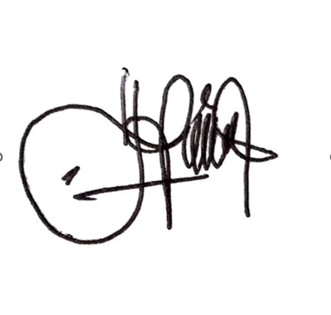 | 17/09/2026
Setya Putri Rahayu |  | 17/09/2026
Nurul Kurniati | 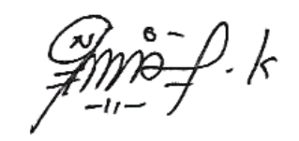 | 17/09/2026
Elly Naila Fauziah |  | 17/09/2026

